Ideation Phase
Brainstorm & Idea Prioritization Template

Date | 6 July 2026
Team ID | SWTID-2026-5839
Project Name | Visualisation of Housing Market Trends
Maximum Marks | 4 Marks

Brainstorm & Idea Prioritization Template:
This brainstorming session was conducted to establish a collaborative framework for analysing the historical housing market dataset. By prioritizing a high volume of visual and analytical concepts, our goal was to determine how to best translate disparate structural attributes (such as living square footage, construction age, and renovation intervals) into clean, interactive Tableau dashboard components. By welcoming out-of-the-box data slicing methods, the team collaboratively built upon individual feature proposals to construct a cohesive, end-to-end data story tailored for real estate buyers and investors.
Reference: "C:\Users\rahul\Downloads\Transformed_Housing_Data2.csv"
This is the core focus of the brainstorm, framed as a "How Might We" statement:
How might we analyse housing market patterns across Indian states identify trends and support better visualisation of housing market trends
using interactive Tableau dashboards?

Key Rules of Brainstorming
• Stay focused on the project objective.
• Encourage creative ideas from every team member.
• Consider multiple visualization techniques.
• Prioritize ideas based on feasibility and impact.
• Validate every visualization using the dataset.
• Build an interactive dashboard for better

Step-1: Team Gathering, Collaboration and Select the Problem Statement
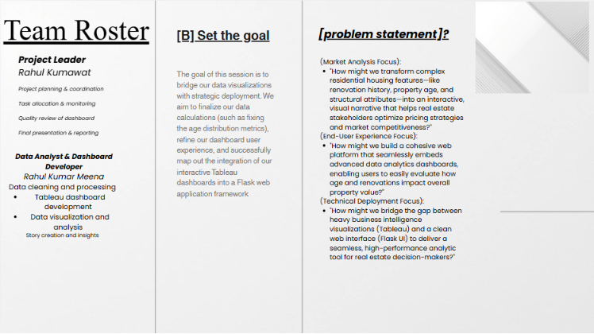
Step-2: Brainstorm, Idea Listing and Grouping
After discussing different analytical approaches, the team grouped similar ideas into three
major categories.
Cluster 1: Interactive Dashboard & Visualization
The team proposed developing an interactive Tableau dashboard that allows users to
Explore Housing market trends Visualizations
Ideas included:
• Develop separate geographical maps for 2019 and 2020 Housing market trends.
• Create interactive bar charts to compare state-wise housing selling.
• Design regional comparison charts to identify differences among Indian regions.
• Build a responsive dashboard combining all worksheets in a single interface.
Cluster 2: Dynamic User Interaction
The second discussion focused on improving user interaction and dashboard flexibility.
Ideas included:
• Add Year, Month, Region, and State filters for dynamic exploration.
• Create Top N and Bottom N parameter-based visualizations.
• Allow dashboard filters to update all worksheets simultaneously.
• Enable users to compare housing trends usage across different time periods.
Cluster 3: Business Insights & Decision Support
The third group focused on generating meaningful business insights.
Ideas included:
• Analyse housing demand before and during the COVID-19 lockdown.
• Identify states with the highest and lowest housing selling.
• Compare housing selling across Eastern, Western, Northern, Southern, and North-
Eastern regions.
• Create a Tableau Story to explain key findings in a logical sequence
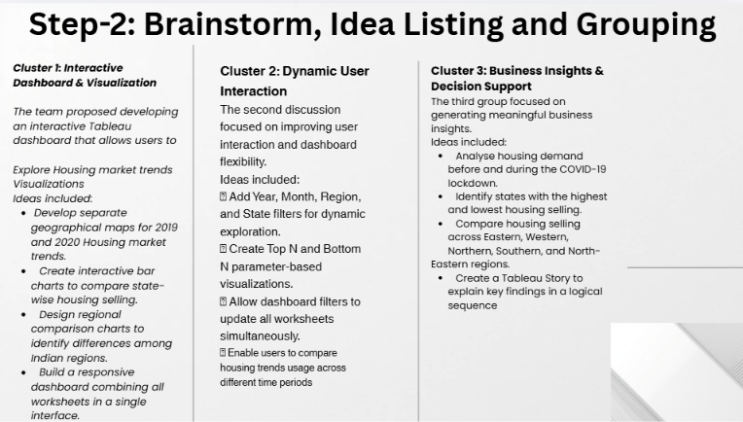

Step-3: Idea Prioritization
After evaluating every idea based on Importance and Feasibility, the team selected the
following priorities.
High Importance / High Feasibility (Top Priorities)
• Develop interactive Tableau dashboards with multiple visualizations.
• Build separate geographical maps.
• Implement dynamic Year, Month, Region, and State filters.
• Create Top N and Bottom N parameter-based analysis.
• Design regional comparison charts for better understanding of Housing Market trands.
High Importance / Low Feasibility (Strategic Long-Term Ideas)
• Integrate live Housing data through APIs.
• Build AI-based housing modals prediction models.
• Add real-time forecasting and anomaly detection.
• Develop automated housing trends market for Builders.
•
Low Importance / High Feasibility (Quick Wins)
• Improve dashboard colour themes and formatting.
• Add informative tooltips to every visualization.
• Include dashboard legends and descriptive titles.
• Enhance navigation using Tableau Story Points.
Low Importance / Low Feasibility (Discarded Ideas)
• Develop a mobile application for dashboard access during the first phase.
• Integrate id-based real-time data.
• Build 3D visualization dashboards.
• Implement voice-controlled dashboard interaction

